Experiment-3

Create a PROPERTY BUYING cloud software application and provide it as

a service using any Cloud Service Provider to demonstrate

Software as a Service (SaaS).

PROCEDURE:

STEP1: GOTO ZOHO.COM

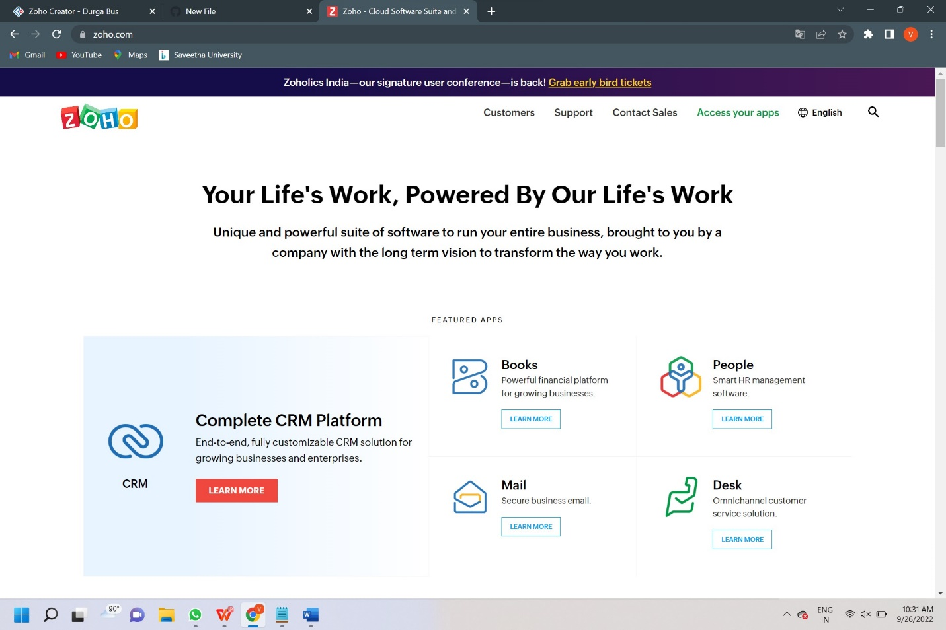

**STEP 2: LOGINTOTHE ZOHO.COM**

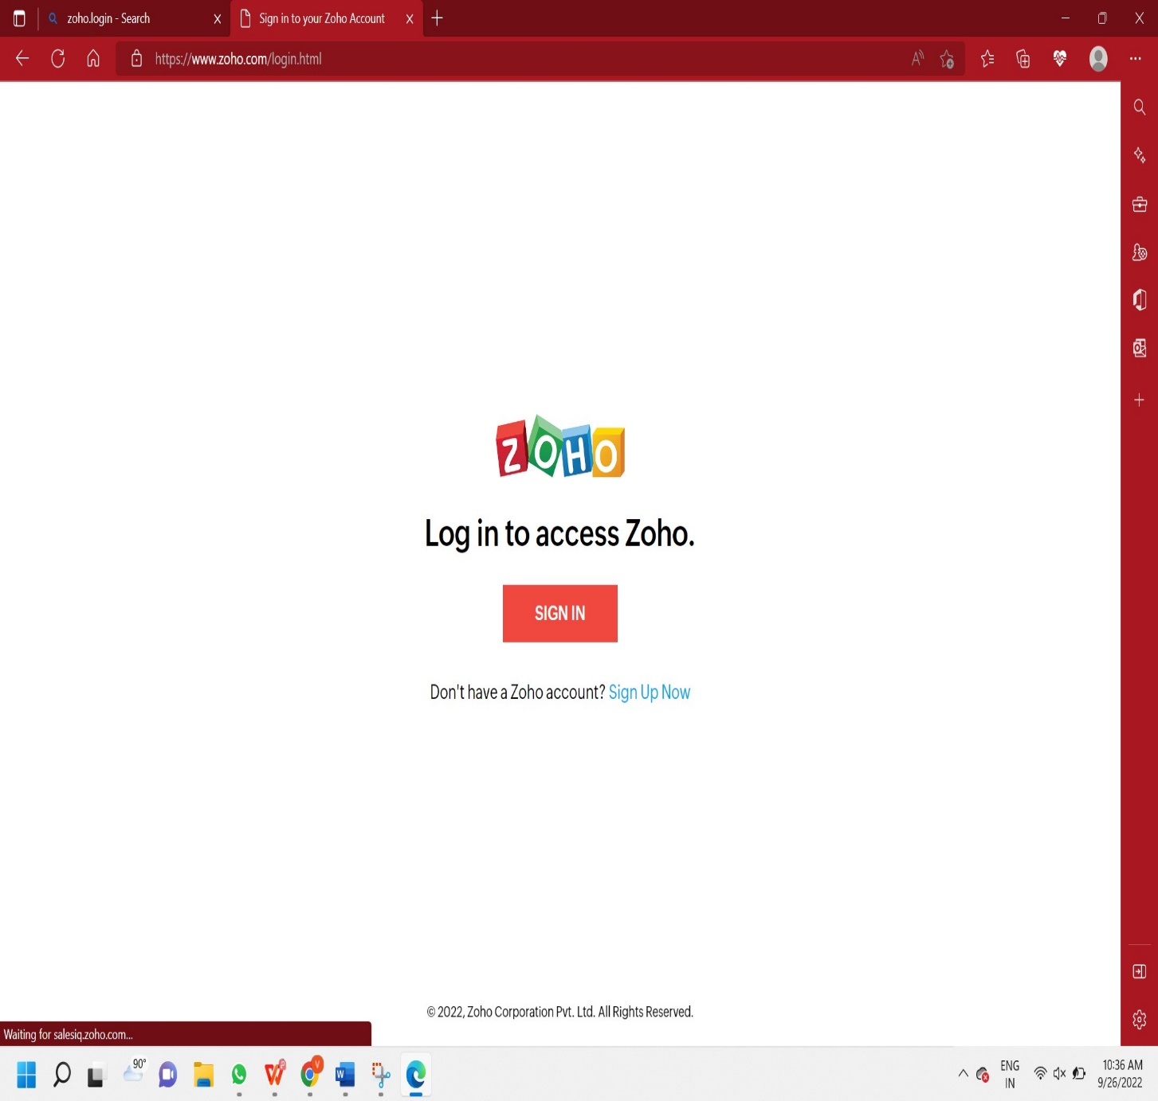

**STEP 3: SELECT ONE APPLICATION**

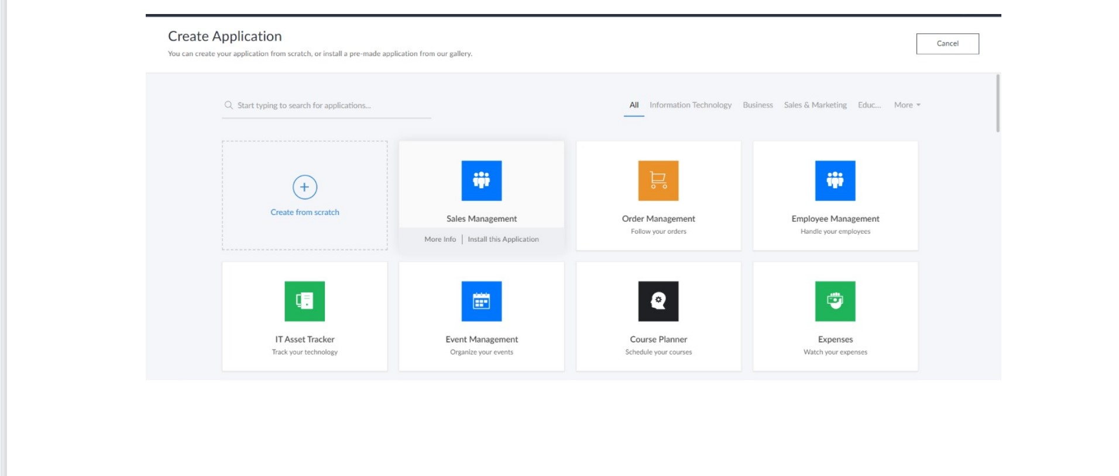

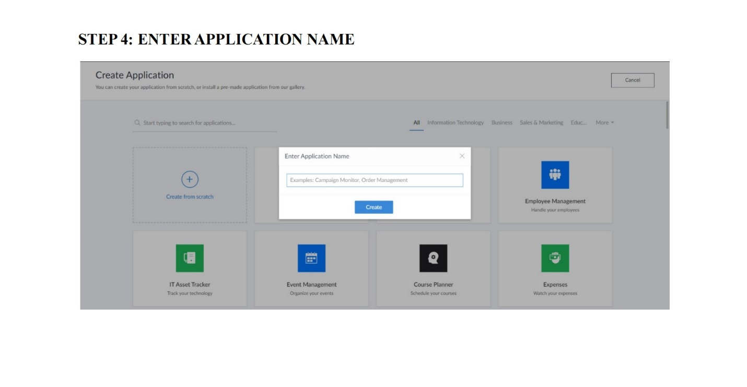

**STEP 5: CREATED NEW APPLICATIO**

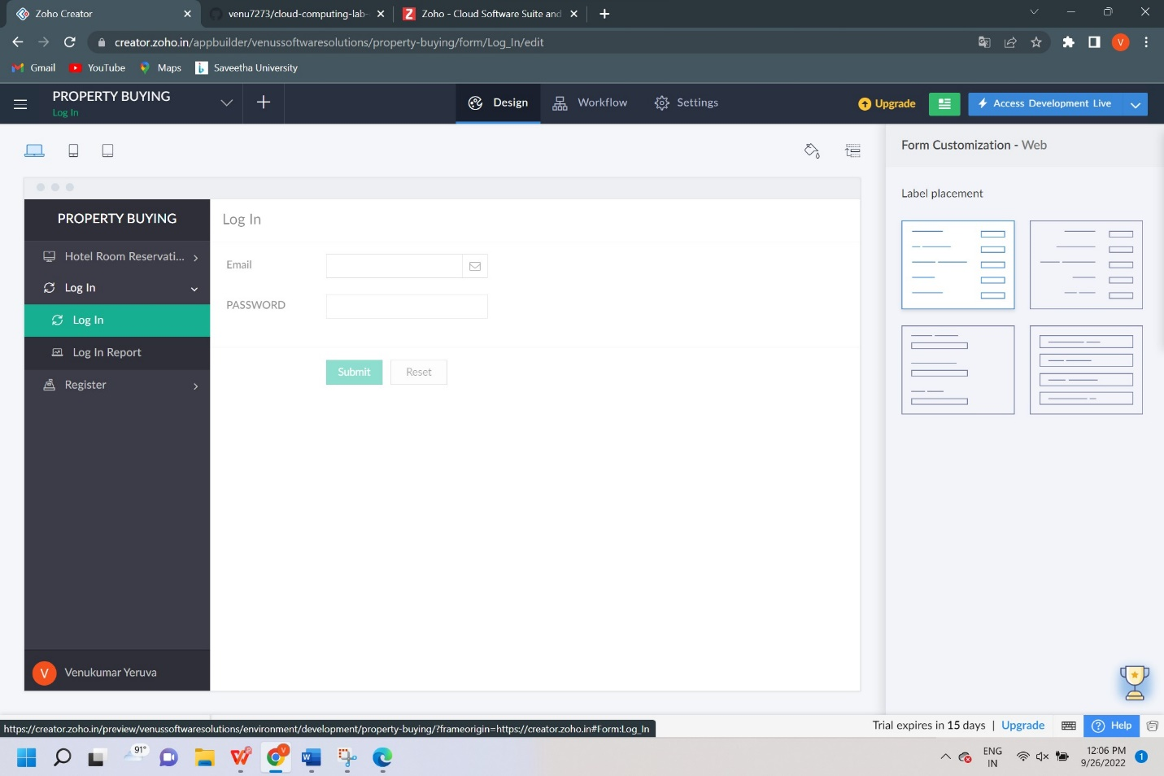

**STEP 6: SELECT ONE FORM**

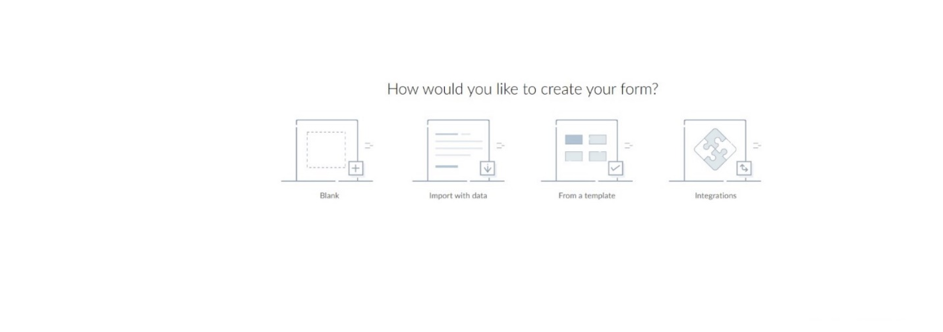

**STEP 7: THE SOFTWARE HASE BEEN CREATED.**

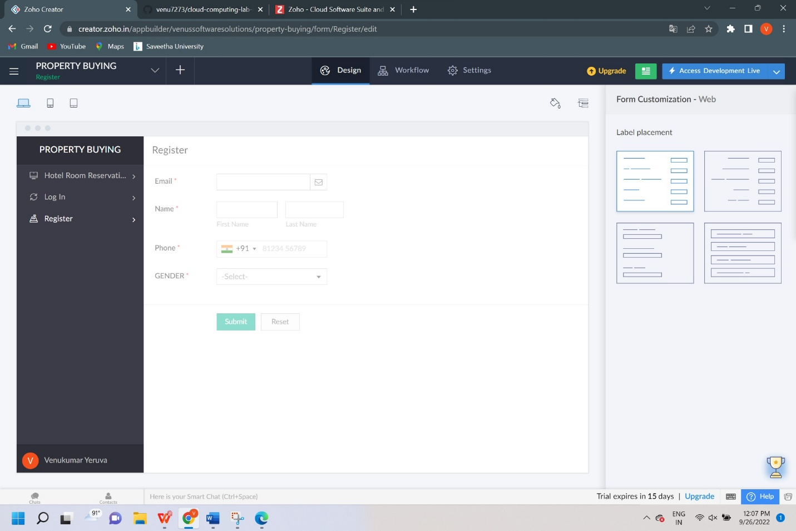

**RESULT:**

